**Lesson 3 Demo 7**

**Managing Clusters with Kubelet**



Steps to be followed:

1. Defining the container runtime
2. Modifying configuration file

**Step 1: Defining the Container runtime**

1. Write the following command to define the container runtime:

***sudo kubelet --container-runtime docker***

| **Note:** We will use Docker container as we do not have other containers installed right now and Docker is the default container. |
| --- |

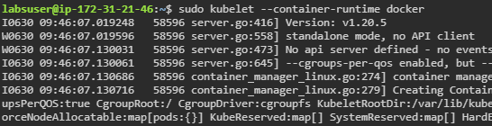

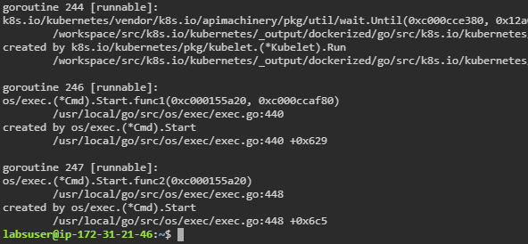

**Step 2: Modifying configuration files**

1. Write the following command to open /var/lib/kubelet/config.yaml:

**sudo *vi /var/lib/kubelet/config.yaml***



1. Write the following code in the file:

***apiVersion: kubelet.config.k8s.io/v1beta1***

***authentication:***

***anonymous:***

***enabled: false***

***webhook:***

***cacheTTL: 0s***

***enabled: true***

***x509:***

***clientCAFile: /etc/kubernetes/pki/ca.crt***

***authorization:***

***mode: Webhook***

***webhook:***

***cacheAuthorizedTTL: 0s***

***cacheUnauthorizedTTL: 0s***

***cgroupDriver: systemd***

***clusterDNS:***

***- 10.96.0.10***

***clusterDomain: cluster.local***

***cpuManagerReconcilePeriod: 0s***

***evictionPressureTransitionPeriod: 0s***

***fileCheckFrequency: 0s***

***healthzBindAddress: 127.0.0.1***

***healthzPort: 10248***

***httpCheckFrequency: 0s***

***imageMinimumGCAge: 0s***

***kind: KubeletConfiguration***

***logging: {}***

***nodeStatusReportFrequency: 0s***

***nodeStatusUpdateFrequency: 0s***

***resolvConf: /run/systemd/resolve/resolv.conf***

***rotateCertificates: true***

***runtimeRequestTimeout: 0s***

***shutdownGracePeriod: 0s***

***shutdownGracePeriodCriticalPods: 0s***

***staticPodPath: /etc/kubernetes/manifests***

***streamingConnectionIdleTimeout: 0s***

***syncFrequency: 0s***

***volumeStatsAggPeriod: 0s***

***topologyManagementStrategy: best-effort***

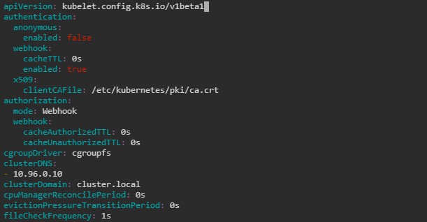

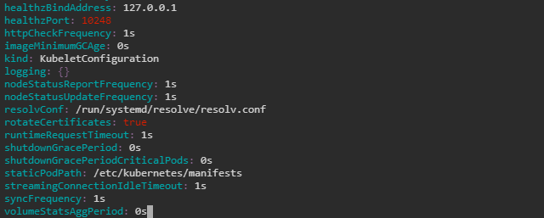

| **Note:** Change values for various frequency and timeout fields. Press the **esc** button and type **:wq** to save the file and exit the **Vi** editor. |
| --- |

1. Type the following command to apply the changes:

***sudo systemctl daemon-reload***

***sudo systemctl restart kubelet***

